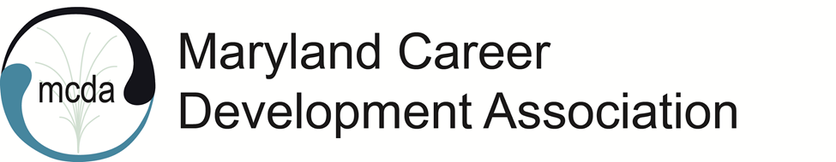
MCDA Board Meeting
Friday, April 8, 2022, 11:00 am
Virtual via Zoom

Present: Natasha OrtizFortier, Kimberly Mills, Viktoriya Selden, Marilyn Maze, Natalie Kauffman, Tessa McKenzie, Maria Schaffer, Karol Taylor, Rose Howard (joined late: Jennifer Longmire-Wright and Staci Parker)

President OrtizFortier called the meeting to order at 11:02 am.
President OrtizFortier welcomed everyone to the meeting.
Minutes from the MCDA February 2022 virtual meeting were approved.

Bylaws and Membership Updates
Natasha: The Bylaws state that elected members of the association (secretary, treasurer, president, and president elect) will have to have membership to MCDA, NCDA, ACA, and MCA effective July 2022.
- This information should be explicit and known when asking people to run for the next term.
Karol: There’s no proxy next year. President of MCDA must attend the MCA board meetings.
- MCA should pay for ACA membership for the board members. MCA can sign up multiple people at ones to get the 10% discount. MCA will look into it. Also, MCDA could use the funds from our workshops to help cover the costs.
- NCDA – Debra Frank can be contacted about separating from MCA. May be worth looking into. We can contact PACDA to see how they separated.
Marilyn: If we go independent, we would have to pay for the account, which is a significant expense.
Maria: The first meeting with the accountant will be this month. MCDA pays 10% of membership dues (up to $500) for the accountant. We have not paid anything for the past 3 years because of the current problems. She has been acting as the accountant and MCDA has not utilized the services. Therefore, the fees were waived. However, the 10% requirement will be reinstated starting July 2022.
- We use many of MCA services, including GoDaddy
- We can pay for MCA, not expensive and important to keep the current leadership. She recommended we stay with MCA.
Natalie: In the past, the members were required to be part of all those organizations. Later, this requirement was taken out of the Bylaws. Now it is coming back. This is not new. In the past, one of the previous presidents was a social worker and did not need all the memberships, so the Board covered the costs.

MCDA Spring 2022 Conference - Natasha OrtizFortier began the discussion on the updates:
Speakers and all other information have been posted on the website.
Jennifer created a drop box to promote the conference.
Rose: Seems like Sharon’s presentation was recycled. She needs to send her resume to be eligible for CEUs. Sharon will not get the full CEU credit if Natasha is speaking too (introducing).
- Kimberly will ask Dr. Givens for the resume. (She submitted her LinkedIn and NCDA bio)
- Natalie suggested calling Alicia regarding Sharon’s resume.
- The time slot is 75 minutes for Natasha and Sharon. Natasha will speak for 15 minutes. Sharon will speak for 1 hour. Altogether, this will total 4.75 CEUs.
Rose: had problems with registering for the conference on the website.
- Marilyn and Maria said to contact them for help.
Maria: 22 registered so far.
Karol: Some may register last minute.
Natasha: We will meet for the technical piece of the conference.
Jennifer: created the folder and will continue to market. Sending out marketing to the presenters
- Will do weekly marketing
- Let her know if anyone else needs to be sent marketing
Natasha will follow up with Natalie about the awards.

Programming – Kimberly Mills
Ronnie White will present in May
Karol provided informaiton for Jeff Slotzfus (703-623-8708) from University of Maryland who is willing to do a free presentation on LinkedIn.

Other Updates
Tessa thanked Marilyn for the work she’s been doing and finding Staci Parker for the newsletter.
- Natalie sent her picture and bio for the newsletter. She also promised an article for the new issue.
- Karol contributed an article. Noted that a president’s letter is needed.
Tessa and Natasha have been talking with April Patty regarding taking over Lisa’s role, who will resign after the conference. Lisa is working with her on training.
Maria: To move ahead with April Patty, we need her resume. She needs to become an official contractor. We need to be fiscally aware as we transition.

Treasurer – Maria Schaffer
No updates

Website – Marilyn Maze
She will do what she can to help with the conference

Advocacy Updates – Karol Taylor
She was surprised that we were losing our president elect.
Nothing new beyond her report.
She put together a letter encouraging people to run. Feels that it should go out before the conference so people can start thinking about it.
We can do more workshops to cover the ACA and MCA membership dues so it would not be a deterrent.
Tessa: She submitted her resignation in mid-March to give MCDA enough time.
- Important to have a person in leadership who can be a leader in other organizations with the counseling background.

Newsletter – Staci Parker
She is an I/O Development Psychologist with a private practice.
She did her first newsletter. Working with wild apricot. Next issue will be better.
Asked for everyone to send her their professional photo with a brief bio.

No updated from Latara Jones on National Career Development Month

Adjournment 12:03
Minutes taken by Viktoriya Selden

Next Meetings:
- Friday, April 22, 2022 11:00 a.m.-12:30 p.m. (MCDA Conference Rehearsal and Planning)
- MCDA Conference & Networking Happy Hour _Thursday, April 28

- Friday, May 8, 2022 11:00 a.m.-12:15 p.m. (MCDA Board Meeting)
- Friday, June 10, 2022 11:00 a.m.-12:15 p.m. (Last MCDA Board Meeting for 2021-22 Leadership Team)

